Psalms for Lent 2010

LENT 1 [YEAR C]

Psalm 91. 1-2, 9-16
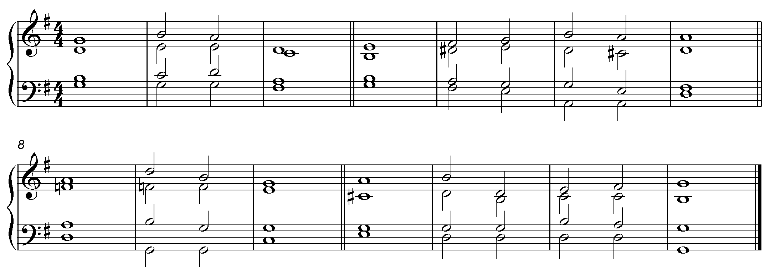

1 Whoever dwells in the shelter of the |Most| High,
and abides under the |shad-ow | of the Al-| mighty.

2 Shall say to the Lord, “My refuge| and my | stronghold,
‘my God, in | whom I | put my |trust.”

9 Because you have made the| Lord your |refuge,
and the | Most | High your | stronghold,

10 There shall no evil | happen to | you,
neither shall any | plague come | near your | tent.

11 For he shall give his angels | charge | over you,
to | keep you in |all your | ways.

12 They shall bear you | in their | hands,
lest you dash your | foot a -| gainst a | stone.

2nd part
13 You shall tread upon the | lion and | adder;
the young lion and the serpent you shall | trample | under | foot.

14 Because they have set their love upon me, therefore will | I de-| liver them
I will lift them up, be- | cause they | know my | name.

15 They will call upon me and | I will | answer them;
I am with them in trouble, I will de-| liver them and | bring them to | honour.

2nd part
16 With long life | will I | satisfy them,
and | show them | my sal-| vation.

Glory to the Father and | to the |Son
and | to the | Ho-ly | Spirit
as it was in the be- |ginning is | now
and shall be for | ev-er | A |-men.

Psalm 91. 1-2, 9-16

1 Whoever dwells in the shelter of the |Most| High,
and abides under the |shad-ow | of the Al-| mighty.

2 Shall say to the Lord, “My refuge| and my | stronghold,
‘my God, in | whom I | put my |trust.”

9 Because you have made the| Lord your |refuge,
and the | Most | High your | stronghold,

10 There shall no evil | happen to | you,
neither shall any | plague come | near your | tent.

11 For he shall give his angels | charge | over you,
to | keep you in |all your | ways.

12 They shall bear you | in their | hands,
lest you dash your | foot a -| gainst a | stone.

2nd part
13 You shall tread upon the | lion and | adder;
the young lion and the serpent you shall | trample | under | foot.

14 Because they have set their love upon me, therefore will | I de-| liver them
I will lift them up, be- | cause they | know my | name.

15 They will call upon me and | I will | answer them;
I am with them in trouble, I will de-| liver them and | bring them to | honour.

2nd part
16 With long life | will I | satisfy them,
and | show them | my sal-| vation.

Glory to the Father and | to the | Son
and | to the | Ho-ly | Spirit;

as it was in the be-| ginning is | now
and shall be for | e-ver | A- | men.

LENT 2 [YEAR C]

Psalm 22. 23-31 (11 point)
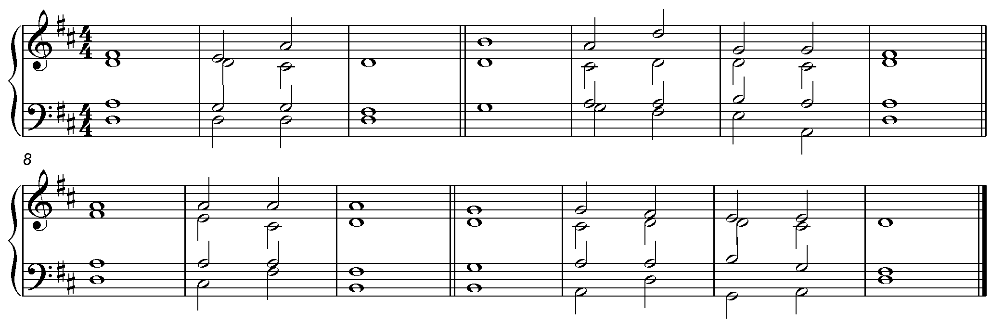
1 The Lord is my light and my salvation; whom then | shall I | fear?
The Lord is the strength of my life; of whom then | shall I | be a- | fraid?

2 When the wicked, even my enemies and my foes, came upon me to | eat up my | flesh,
they | stum -bled | and | fell.

3 Though a host encamp against me, my heart shall | not be a- | fraid;
and though there rise up war against me, yet will I | put my | trust in | him.

4 One thing have I asked of the Lord and that a-| lone I | seek:
that I may dwell in the house of the Lord | all the | days of my | life

5 To behold the fair | beauty of the | Lord
and to | seek his | will in his | temple

6 For in the day of trouble he shall hide me | in his | shelter;
in the secret place of his dwelling shall he hide me and set me | high up- | on a |rock.

7 And now shall he | lift up my | head
above my | ene-mies| round a- | bout me;

8 Therefore I will offer in his dwelling an oblation with | great |gladness;
I will sing and make | mus-ic | to the | Lord.

9 Hear my voice, O Lord, | when I | call;
have | mercy up- | on me and | answer me.

10 My heart tells of your word,| ‘Seek my | face.’
Your |face, Lord, | will I | seek.

11 Hide | not your | face from me,
nor cast your | servant a-| way in dis-| pleasure.

12 You have | been my | helper;
leave me not, neither forsake me, O | God of | my sal-| vation.

2nd part
13 Though my father and my | mother for-| sake me,
the | Lord will | take me | up.

14 Teach me your | way, O | Lord;
lead me on a level path, because of | those who | lie in | wait for me.

15 Deliver me not into the | will of my | adversaries,
for false witnesses have risen up against me, and | those who | breathe out | violence.

16 I believe that I shall see the | goodness of the | Lord
in the| land | of the | living.

17 Wait for the Lord; be strong and he shall | comfort your | heart;
wait | patient-ly | for the | Lord.

Glory to the Father and | to the | Son
and | to the | Ho-ly | Spirit;

as it was in the be-| ginning is | now
and shall be for | e-ver | A- | men.
Psalm 22. 23-31 (10.5 point)
1 The Lord is my light and my salvation; whom then | shall I | fear?
The Lord is the strength of my life; of whom then | shall I | be a- | fraid?

2 When the wicked, even my enemies and my foes, came upon me to | eat up my | flesh,
they | stum -bled | and | fell.

3 Though a host encamp against me, my heart shall | not be a- | fraid;
and though there rise up war against me, yet will I | put my | trust in | him.

4 One thing have I asked of the Lord and that a-| lone I | seek:
that I may dwell in the house of the Lord | all the | days of my | life

5 To behold the fair | beauty of the | Lord
and to | seek his | will in his | temple

6 For in the day of trouble he shall hide me | in his | shelter;
in the secret place of his dwelling shall he hide me and set me | high up- | on a |rock.

7 And now shall he | lift up my | head
above my | ene-mies| round a- | bout me;

8 Therefore I will offer in his dwelling an oblation with | great |gladness;
I will sing and make | mus-ic | to the | Lord.

9 Hear my voice, O Lord, | when I | call;
have | mercy up- | on me and | answer me.

10 My heart tells of your word,| ‘Seek my | face.’
Your |face, Lord, | will I | seek.

11 Hide | not your | face from me,
nor cast your | servant a-| way in dis-| pleasure.

12 You have | been my | helper;
leave me not, neither forsake me, O | God of | my sal-| vation.

2nd part
13 Though my father and my | mother for-| sake me,
the | Lord will | take me | up.

14 Teach me your | way, O | Lord;
lead me on a level path, because of | those who | lie in | wait for me.

15 Deliver me not into the | will of my | adversaries,
for false witnesses have risen up against me, and | those who | breathe out | violence.

16 I believe that I shall see the | goodness of the | Lord
in the| land | of the | living.

17 Wait for the Lord; be strong and he shall | comfort your | heart;
wait | patient-ly | for the | Lord.

Glory to the Father and | to the | Son
and | to the | Ho-ly | Spirit;

as it was in the be-| ginning is | now
and shall be for | e-ver | A- | men.

Psalm 22. 23-31 [13 point for lesson reader’s sheet]
1 The Lord is my light and my salvation; whom then | shall I | fear?
The Lord is the strength of my life; of whom then | shall I | be a- | fraid?

2 When the wicked, even my enemies and my foes, came upon me to | eat up my | flesh,
they | stum -bled | and | fell.

3 Though a host encamp against me, my heart shall | not be a- | fraid;
and though there rise up war against me, yet will I | put my | trust in | him.

4 One thing have I asked of the Lord and that a-| lone I | seek:
that I may dwell in the house of the Lord | all the | days of my | life

5 To behold the fair | beauty of the | Lord
and to | seek his | will in his | temple

6 For in the day of trouble he shall hide me | in his | shelter;
in the secret place of his dwelling shall he hide me and set me | high up- | on a |rock.

7 And now shall he | lift up my | head
above my | ene-mies| round a- | bout me;

8 Therefore I will offer in his dwelling an oblation with | great |gladness;
I will sing and make | mus-ic | to the | Lord.

9 Hear my voice, O Lord, | when I | call;
have | mercy up- | on me and | answer me.

10 My heart tells of your word,| ‘Seek my | face.’
Your |face, Lord, | will I | seek.

11 Hide | not your | face from me,
nor cast your | servant a-| way in dis-| pleasure.

12 You have | been my | helper;
leave me not, neither forsake me, O | God of | my sal-| vation.

2nd part
13 Though my father and my | mother for-| sake me,
the | Lord will | take me | up.

14 Teach me your | way, O | Lord;
lead me on a level path, because of | those who | lie in | wait for me.

15 Deliver me not into the | will of my | adversaries,
for false witnesses have risen up against me, and | those who | breathe out | violence.

16 I believe that I shall see the | goodness of the | Lord
in the| land | of the | living.

17 Wait for the Lord; be strong and he shall | comfort your | heart;
wait | patient-ly | for the | Lord.

Glory to the Father and | to the | Son
and | to the | Ho-ly | Spirit;

as it was in the be-| ginning is | now
and shall be for | e-ver | A- | men.

LENT 3 [YEAR C]

Psalm 63. 1–8

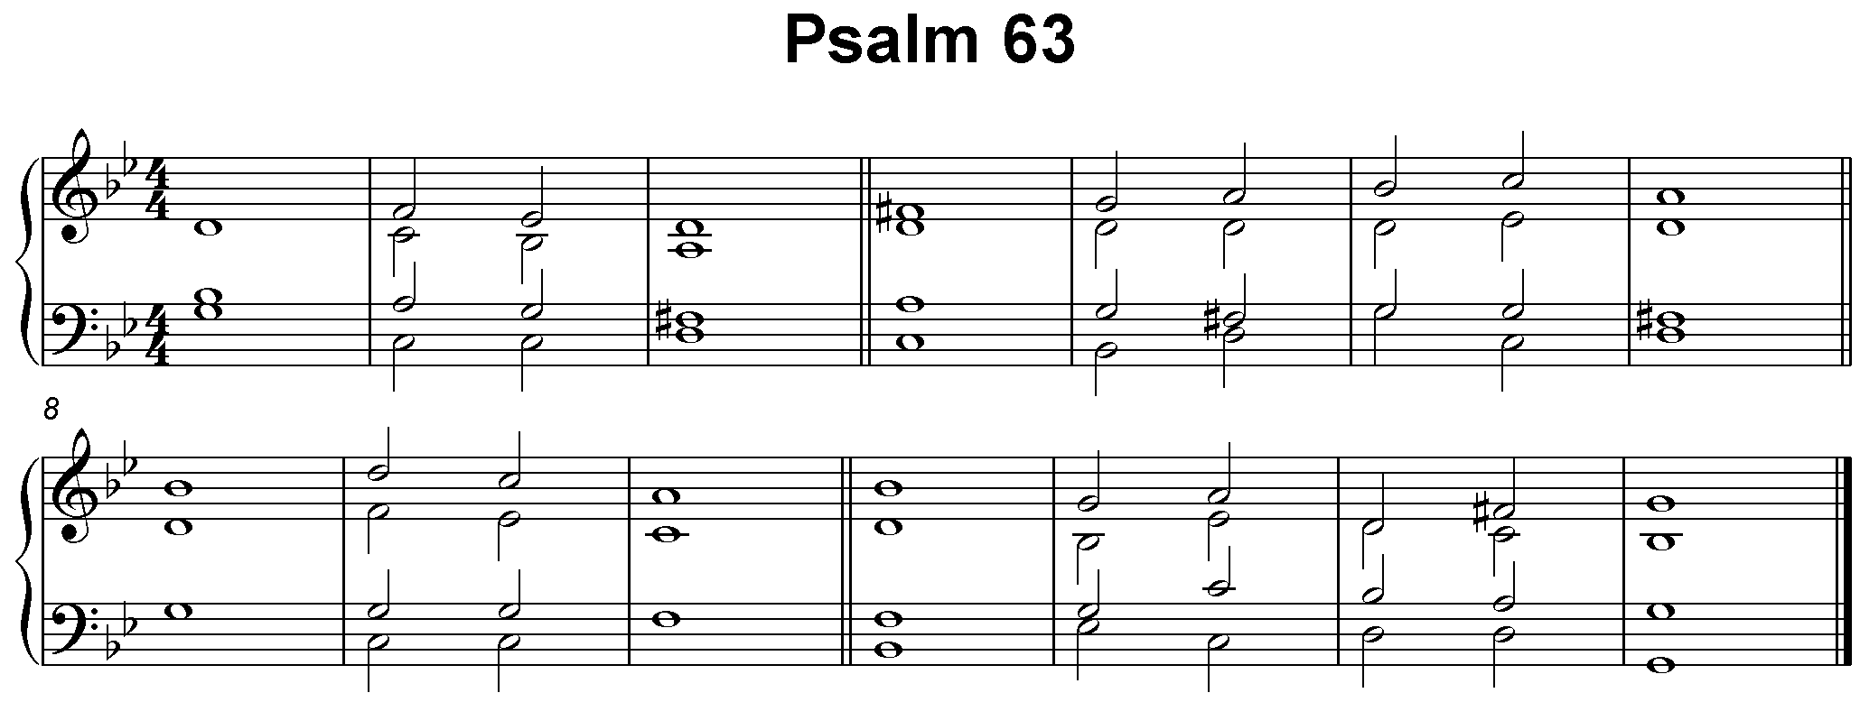

1 O God, you are my God; | eagerly I | seek you;
my | soul is a | thirst for | you.

2 My flesh | al-so | faints for you,
as in a dry and thirsty | land where there | is no | water.

3 So would I gaze upon you in your | ho-ly | place,
that I might behold your | pow-er | and your | glory.

4 Your loving-kindness is better than | life it- | self
and | so my | lips shall | praise you.

5 I will bless you as | long as I | live
and lift up my | hands | in your | name.

6 My soul shall be satisfied, as with | marrow and | fatness,
and my mouth shall | praise you with | joy-ful | lips,

7 When I remember you up-| on my | bed
and meditate on you in the | watch-es | of the | night.

8 For you have | been my | helper
and under the shadow of your | wings will | I re-| joice.

9 My | soul | clings to you;
your |r ight hand shall | hold me | fast.

10 But those who seek my soul | to des-| troy it
shall go | down to the | depths of the | earth;

11 Let them fall by the | edge of the | sword
and be-| come a | portion for | jackals.

12 But the king shall rejoice in God; all those who swear by him | shall be | glad,
for the mouth of those who speak | lies | shall be | stopped.

Glory to the Father and | to the | Son
and | to the | Ho-ly | Spirit;

as it was in the be-| ginning is | now
and shall be for | e-ver | A- | men.

Psalm 63. 1-9 (11pt type)

1 O God, you are my God; | eagerly I | seek you;
my | soul is a | thirst for | you.

2 My flesh | al-so | faints for you,
as in a dry and thirsty | land where there | is no | water.

3 So would I gaze upon you in your | ho-ly | place,
that I might behold your | pow-er | and your | glory.

4 Your loving-kindness is better than | life it- | self
and | so my | lips shall | praise you.

5 I will bless you as | long as I | live
and lift up my | hands | in your | name.

6 My soul shall be satisfied, as with | marrow and | fatness,
and my mouth shall | praise you with | joy-ful | lips,

7 When I remember you up-| on my | bed
and meditate on you in the | watch-es | of the | night.

8 For you have | been my | helper
and under the shadow of your | wings will | I re-| joice.

9 My | soul | clings to you;
your |r ight hand shall | hold me | fast.

10 But those who seek my soul | to des-| troy it
shall go | down to the | depths of the | earth;

11 Let them fall by the | edge of the | sword
and be-| come a | portion for | jackals.

12 But the king shall rejoice in God; all those who swear by him | shall be | glad,
for the mouth of those who speak | lies | shall be | stopped.

Glory to the Father and | to the | Son
and | to the | Hol-y | Spirit;

as it was in the be- | ginning is |now
and shall be for | ev-er. |A- | men.

LENT 4 [YEAR C] Mothering Sunday

Psalm 127. 1-4

1 Unless the Lord | builds the | house,
those who | build it | labour in | vain.

2 Unless the Lord | keeps the | city,
the | guard keeps | watch in | vain.

3 It is in vain that you hasten to rise up early and go so late to rest, eating the | bread of | toil,
for he | gives his be- | lov-ed | sleep.

4 Children are a heritage | from the | Lord
and the fruit of the | womb | is his | gift.

5 Like arrows in the | hand of a | warrior,
so are the | child-ren | of one’s | youth.

6 Happy are those who have their | quiv-er | full of them:
they shall not be put to shame when they dispute with their ene-mies | in the | gate.

Glory to the Father and | to the | Son
and | to the | Ho-ly | Spirit;

as it was in the be-| ginning is | now
and shall be for | e-ver | A- | men.

LENT 5 Passion Sunday [YEAR C]
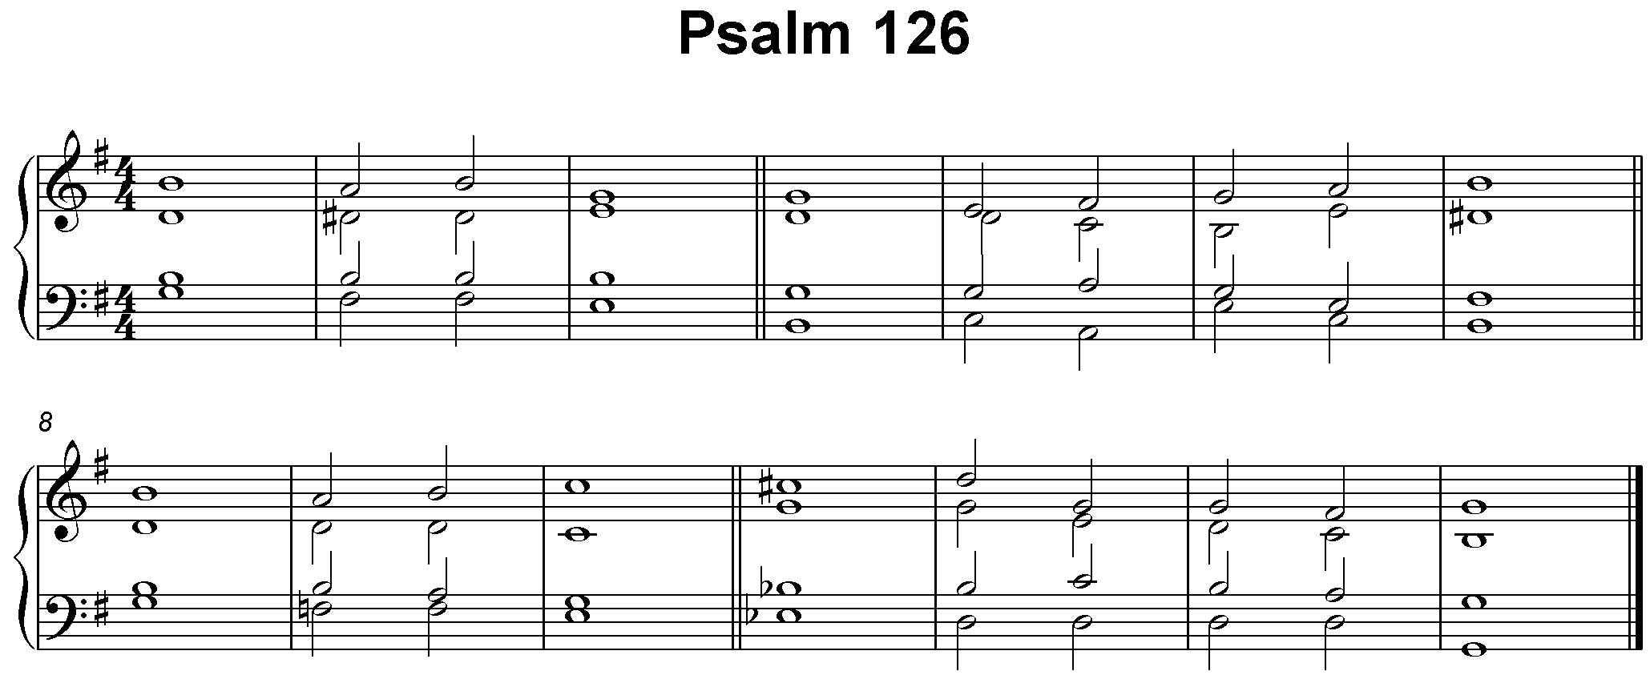

Psalm 126

1 When the Lord restored the | fortunes of | Zion,
then were | we like | those who | dream.

2 Then was our mouth | filled with | laughter
and our | tongue with | songs of | joy.

3 Then said they a-| mong the | nations,
‘The | Lord has done | great things | for them.’

4 The Lord has indeed done | great things | for us,
and | there-fore | we re-| joiced.

5 Restore again our | fortunes, O | Lord,
as the | river beds | of the | desert.

6 Those who | sow in | tears
shall | reap with | songs of | joy.

2nd part
7 Those who go out weeping, | bearing the | seed,
will come back with shouts of joy, | bearing their | sheaves | with them.

Glory to the Father and | to the | Son
and | to the | Ho-ly | Spirit;

as it was in the be-| ginning is | now
and shall be for | e-ver | A- | men.

